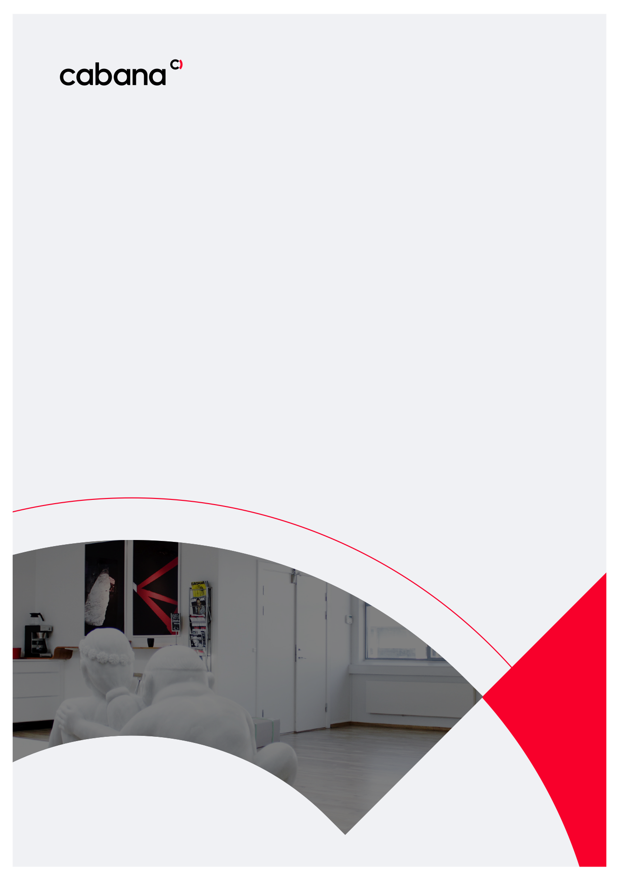

AD Azure integration

Kommuneplatformen

How-to-guide

Copenhagen, May 2021

|  |
| --- |
|  |

# Configuring Azure Active Directory Kommuneplatformen login

## Prerequisites

You have added or imported users into your Azure Active Directory and assigned roles to them.

## Baseline registration

Login to Azure portal <https://portal.azure.com/>

Go to Azure Active Directory dashboard <https://portal.azure.com/#blade/Microsoft_AAD_IAM/ActiveDirectoryMenuBlade/Overview>

Choose App Registration and click New registration

Fill out App details

Make sure that you add the trailing slash in the Redirect URI.

Add the following redirect URLs for local and test environments.

Url: [**https://baseline.localtest.me/umbraco/**](https://baseline.localtest.me/umbraco/)

Make sure that you add the trailing slash in the Redirect URI.

Please send the following App information to Cabana.

* Application (client ID)
* Directory (tenant) ID
* All the redirect URIs
* **Admin** role name alias and **Editor** role name alias?

